PICAP Final report

Brendan Bickford

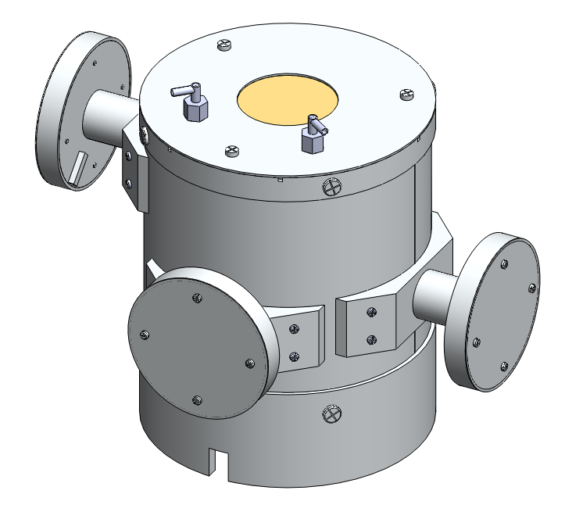

Contents

Executive Summary 3

Introduction 3

Instrument concept 3

Design Criteria 4

Design process 5

Photon detection and Scintillation material 5

Driving Dimensions and Design Constraints 6

Solid state detectors 1-3 6

C plastic Scintillator 7

Teflon 9

G crystal scintillator 10

Anti-Coincident scintillator 13

Solid state detectors 4 15

Mushroom assembly 18

Full assembly 19

Test plan 21

Mechanical Design constraints 21

Test procedure 21

Light leaks 21

Cross talk 21

Particle accelerator 21

Testing solid-state detectors 21

Procedure 22

steps 22

Analysis 25

Analysis 26

Absorption probability 27

# Executive Summary

The goal of this project is to prove a new method for identifying moderate energy positrons and negatrons by building a working prototype space flight instrument. This is a comprehensive report of the mechanical design for the PICAP instrument. In this report the design process is explained out in detail. This design process explains reason behind the design of this instrument to ensure a working and practical instrument. Main considerations that were taking into account when designing this instrument were; Machining and Assembly of the instrument, Minimizing weight while keeping rigidity, Keeping cost of building the instrument relatively low, having practical design alterations to make this a full space instrument and Providing sufficient and accurate particle measurements.

# Introduction

This instrument concept is new method for detecting moderate energy (2-10 MeV) positrons and negatrons in space. The current method for measuring these particles is by using a magnet spectrometer. Magnet spectrometers typically weigh greater than 10 kg, use more than 10 watts of power and require a magnet. The goal of the proposed PICAP design is to reduce these resources to provide an alternative, and more attractive space flight instrument. We estimate a flight instrument to have a weight less than 4 kg, power draw of less than 3 Watts and no magnet. As a space flight instrument this resource allotment will would make the PICAP instrument a much more desirable alternative.

The PICAP instrument works by using the dE/dx method versus residual energy technique to detect particles. Particles will cross various solid state detectors and the deposit their residual energy into a scintillation material. Positrons that ionize in the scintillation material will annihilate and produce two 511 keV photons. These photons will be detected by multiple crystal scintillators surrounding the central scintillation material. Unwanted particle data will be neglected by using scintillation material all around the instrument along with a large solid state detector at the bottom of the device.

# Instrument concept

The figures below show the original instrument concept for the PICAP telescope. D1,D2,D3 and D4 are the solid state detectors, C is the center plastic scintillation material. G1,G2,G3, and G4 are the crystal scintillation material and S is the surrounding plastic scintillation material called the Anti-coincident.

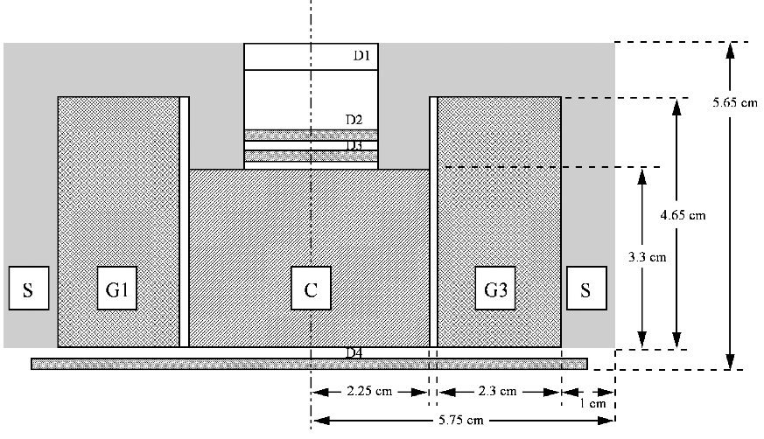

**Figure 1: Cross section of proposed instrument**

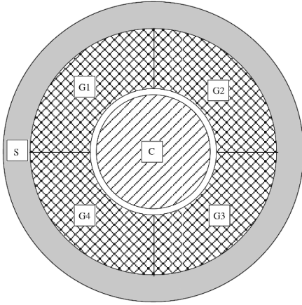

**Figure 2: Top view of proposed instrument**

# Design Criteria

The goal for this project is to make a practical working prototype for the space flight instrument. In order to design this, many aspects had to be considered in the design process. Since this method has not been tested yet, it would be very impractical, due to the high cost, to design a complete space flight instrument to test. This design focuses on making an instrument that would be comparable to a full space ready instrument but at a much lower cost.

The most important aspect of this design was to ensure that particle detection would be an accurate reflection of a space flight instrument. This became fairly difficult when trying to keep the cost of the instrument relatively low. To keep the cost low and the assembly process reasonably easy, the components of the device were made as simple as possible. This would not be the case in the space flight instrument where mass and rigidity would far outweigh the machining and assembly cost. These simple parts make the instrument larger than the space flight instrument and put more material where less is preferred. In some cases the extra material will have adverse effects on the particle detection which are taken into consideration with the prototype. Simulation runs with the Monte Carlo program EGS4 were performed based on the mechanical design to ensure the design will meet the particle detection requirements .

# Design process

This section of the report explains reasoning behind the design, materials, dimensions and parts. This section is broken down into sub assemblies so they could be easily explained.

## Photon detection and Scintillation material



The Center and Anti-coincident scintillators (C and S) are required to be made from plastic in order to ionize the particles within our given energy range. This means that a photomultiplier tube is our only option to detect scintillation since the resolution of a photodiode would not suffice. With this in mind, a practical photomultiplier tube for this instrument had to be used. This photomultiplier tube had to be ruggedized for use in space flight and preferably the smallest size possible. For this design the model R5611A, from [Hamamatsu Photonics](http://www.hamamatsu.com/) was chosen. This tube became one of the driving dimensions of the design. This PMT was ordered with the socket base, however the semi flexible flight leads were cut and soldered to a circuit board. A Mu-metal shield was designed based on the R5611A photomultiplier tube and will be attached to each of the 7 photomultiplier tubes. This process is shown in the procedure.

The material for the G scintillation material was proposed in the design as cesium iodide. However, other materials for these scintillators were researched under two requirements; the material must not be hygroscopic to ensure atmospheric water doesn't affect the crystal and that it must have equivalent or better probability of absorption than that of the proposed design. It was found that [bismuth germanate](http://en.wikipedia.org/wiki/Bismuth_germanate) would be a better substitute. Calculations show that [bismuth germanate](http://en.wikipedia.org/wiki/Bismuth_germanate) would save mass while still having the same absorption probability of annihilation photons as cesium iodide. For the same absorption probability only .94 cm [bismuth germanate](http://en.wikipedia.org/wiki/Bismuth_germanate) would be needed compared to the 2.3 cm of cesium iodide. The decision was made to change the material based on the ability to make the entire size of the device smaller. These calculations can be found in the appendix.

## Driving Dimensions and Design Constraints

The size and dimension constrictions for this design became the size center plastic scintillator, the size of the G crystal scintillators, the use of Teflon around each scintillator, the placement of the 4 solid state detectors, the photomultiplier tubes, and the corresponding circuit boards. Once the size requirements that would provide efficient and accurate particle measurements for each of these parts were determined, the rest of the telescope could be designed around them. There were design constraints that had to be taken into account when designing this instrument. The design constraints are important to ensure that parts of the instrument are not harmed during assembly and application of the device.

The design constraints included;

* + **Light tightness** - This instrument was designed to exclude all ambient light
    - This protected the BGO from UV light
    - This ensured light didn't interfere with the light detection of the photomultiplier tubes
  + **Reflecting light** -Teflon was used around scintillators to reflect light towards the opening face of the photomultiplier tubes
    - This was to ensure light was not lost within the scintillation material
  + **Cross talk** – Teflon and Aluminum was used around each of the scintillators to ensure light would not cross from one to another
    - If cross talk was allowed, particles could not be properly Identified
  + **7 Circuit boards** and corresponding wires had to be included for the photomultiplier tubes and solid state detectors
    - Each photomultiplier tube required its own respective dynode circuit board and wires leading outside the instrument to the electronics
  + **Purging** – purge ports were required to exclude contamination
    - The solid state detectors required nitrogen flow in order to exclude contamination
  + **Faraday cage** - Instrument was required to act as a faraday cage in order to exclude electromagnetic interference
    - Electromagnetic interference would cause noise in the signals and make this an ineffective instrument
  + **Assembly** - Designed with Assembly + Disassembly capabilities
    - This instrument was designed with the capability to assemble and disassemble if required

### Solid state detectors 1-3

The three solid state detectors at the entrance to the device drive both the dimensions for the window opening at the entrance of the telescope and the size of the C scintillator. The dimension that will affect the size of the window and C scintillator is the total width of the column assembly that hold the solid state detectors in place. This column assembly was designed as a way of housing the solid state detectors securely in place, while providing a path for the lead wires and providing a safe assembly procedure to protect the solid state detectors. This design was a reuse of an older design off the ADIS prototype telescope.

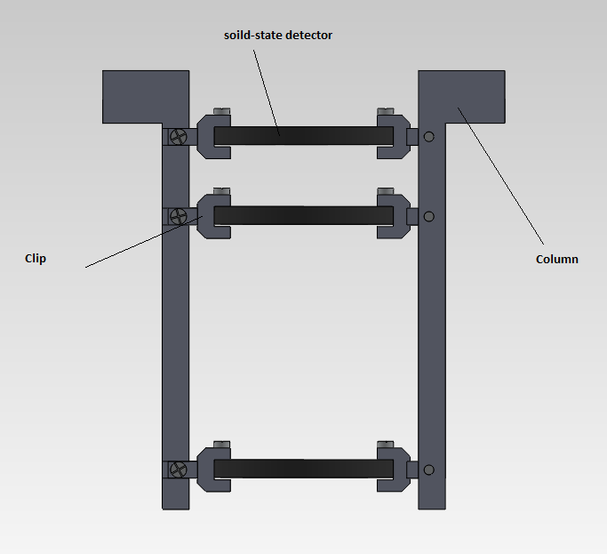

**Figure 3: cross section of column assembly**

### C plastic Scintillator

The C scintillator became a huge driving dimension in the design due to the fact it was placed right in the center of the telescope. The size of the this scintillator was originally proposed to have a radius of 2.25 cm but this had to be changed to 2.55 cm due to considerations of various particle paths. In order for the instrument to measure energy loss properly, any particle going through the 3 solid state detectors at the opening of the device must proceed to enter the C scintillator. This means at the most extreme angle, the particle will enter the edge of the active area on the top solid state detector, continue to the opposite bottom edge of the active area of the bottom solid state detector and continue into the C scintillator. This is shown in figure 4.

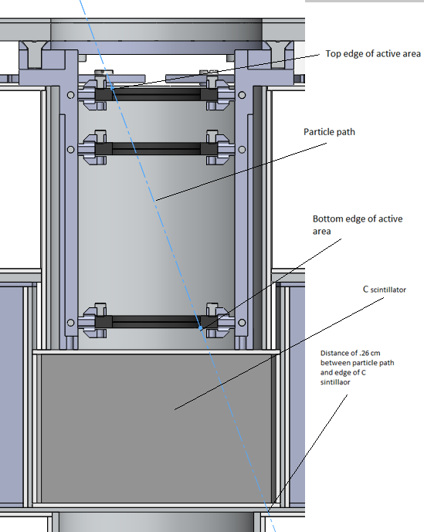

**Figure 4: Extreme angle of particle entry**

Figure 4 shows the extreme angle entry for a given particle, as shown the C scintillator was designed to account for this path. This extreme angle does not account for scattering particles that could still leave energy in the top solid state detectors and not enter the C scintillator, however at this time it is believed this design will suffice. The C scintillator also must be coated all around with Teflon so that light created by the particle will bounce around till it can be read by the photomultiplier tube. This also means that the C scintillator cannot be made as a full 360 degree circle since the photomultiplier tube must be adhered to one side.

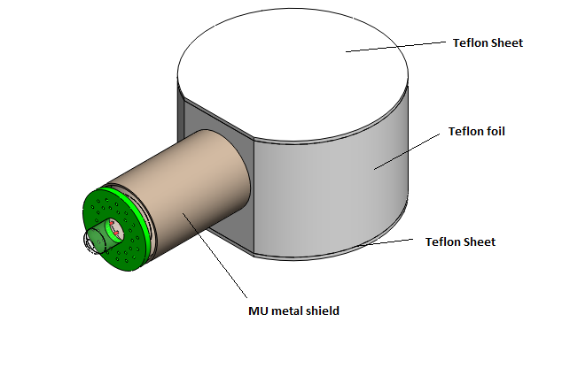

**Figure 5: Isometric view of C scintillator covered in Teflon with attached MU metal shield**

### Teflon

In this design Teflon needs to coat each scintillator on all sides. In order to do this smooth Teflon in 1mm thick sheets were used for the top and bottom of each scintillator and 1.016 mm (.04 inch) foil that could be wrapped around was used to surround the side of each scintillator. In ordered to increase the reflective properties of the Teflon, the Teflon will be scuffed up with steel wool to roughen the surface.

Teflon has been quite difficult to design around due to the fact that it needs to be flush around all sides of each of the scintillators. Since the scintillators do not have uniform shapes and there is no way of adhering Teflon, extra structural support is needed to support the Teflon. This extra structural support adds unwanted mass but is required.

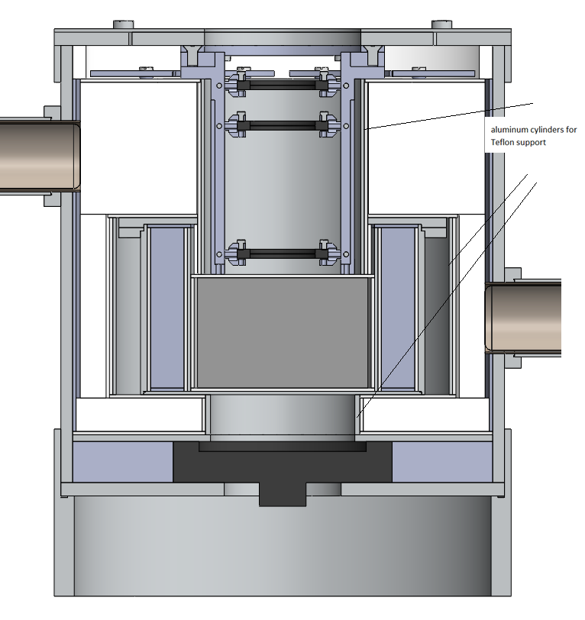

**Figure 6: cross section showing extra support for Teflon**

### G crystal scintillator

As shown with calculations, the minimum required size for the G crystal made from [bismuth germanate](http://en.wikipedia.org/wiki/Bismuth_germanate) was found to be .9353. Referring to figure 2: Top view of proposed instrument, it is shown that [bismuth germanate](http://en.wikipedia.org/wiki/Bismuth_germanate) is 360 degrees around surrounding the center scintillator. However, due to the required read out device, the photo multiplier tube, 360 degrees of BGO was unattainable. Figure 7 shows the best acquired angle given the size of the BGO and PMT.

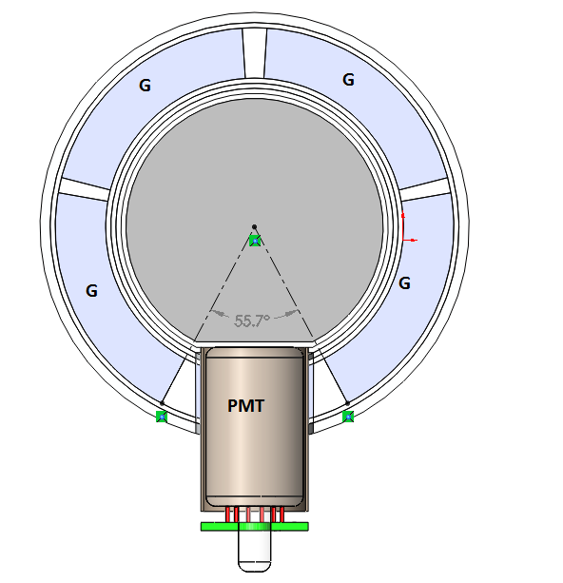

**Figure 7: Top cross section view of annular BGO segments**

This means [bismuth germanate](http://en.wikipedia.org/wiki/Bismuth_germanate) is being driven by the size of the C. Knowing the required dimensions for C from the extreme angle entry, a structure was designed to house the G and C scintillator along with their respective Teflon and Photomultiplier tubes.

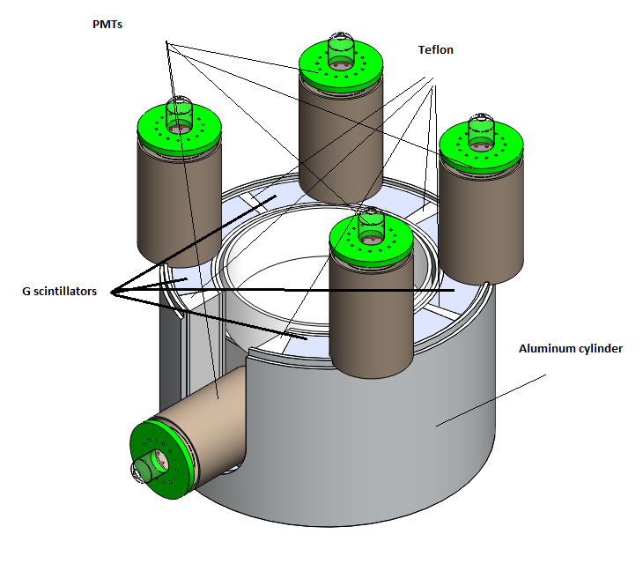

**Figure 8: Housing for C and G scintillator**

This housing design shows two thin walled tube aluminum cylinders that will hold all components inside stable. A bottom plate (not shown) will be adhered to the outer cylinder as a base. This will be adhered rather than machined in order to keep the parts simple and cheap. This is the same with the flanges that are holding the photomultiplier in the vertical direction. It would be necessary to make these one piece in the space flight instrument, but for the prototype, adhering these pieces will suffice.

The inner cylinder has a 1mm thickness, to provide the best particle detection, this needs to be as thin as possible. For a practical prototype this 1mm thickness was decided on based on the thinnest aluminum could be machined within a reasonable budget. For the actual space flight instrument this will be made thinner and with titanium to ensure the best energy measurements and to save mass.

This assembly also includes, but does show in figure 8, a layer of Teflon over the top of the G scintillator and an aluminum cover that is screwed in by four machine screws.

### Anti-Coincident scintillator

The Anti-Coincident scintillator is designed to detect particles that do not enter through the front window of the telescope. In order for this telescope to accurately detect and identify positrons and negatrons, energy must be deposited in the three solid state detectors and the C scintillator. Therefore the anti-scintillator is designed to detect particles that enter the telescope from any direction other than the front window so they can be excluded from analysis. In order to ensure the anti-coincident efficiently measures all particles that enter from varies directions, it was attempted to make this scintillator at least 1cm thick in all areas where particles could enter the device and not trigger all three of the top solid state detectors and the C scintillator.

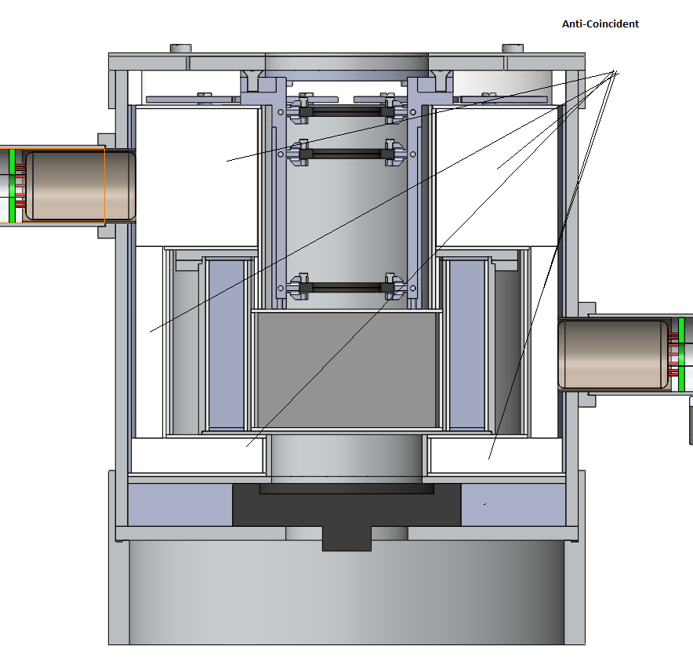

**Figure 9: Section view, Anti scintillator**

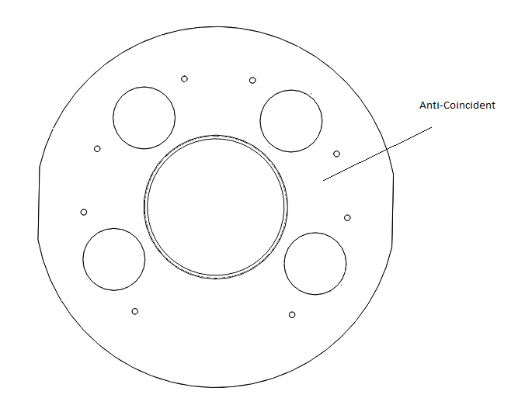

**Figure 10: Top view, Anti Scintillator**

Figure 10 shows the top of the Anti-Scintillator. The Anit Coincident is tapped so nylon screw cans be used, along with nylon spacers, to secure the circuit boards for each of the vertical PMT's attached to the BGO. The circuit boards are shown in figure 11.

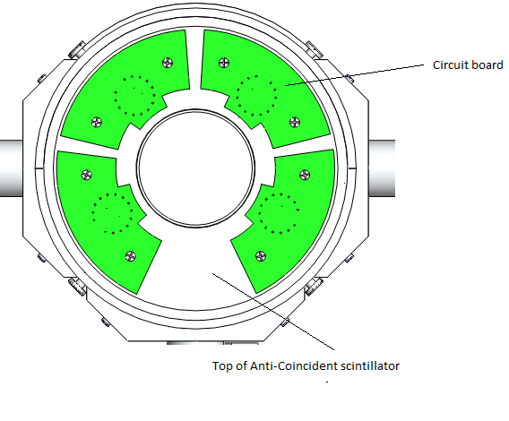

**Figure 11: Top view, Anti Scintillator with circuit boards**

### Solid state detectors 4

The purpose of solid state detector 4 is to detect heavy particles that enter the instrument. If a particle is able to trigger the top three solid state detectors and continue all the way through the C scintillator, it will be detected by D4. Figure 12 shows D4 and a particle path within the telescope. Figure 13 shows the housing assembly for D4.

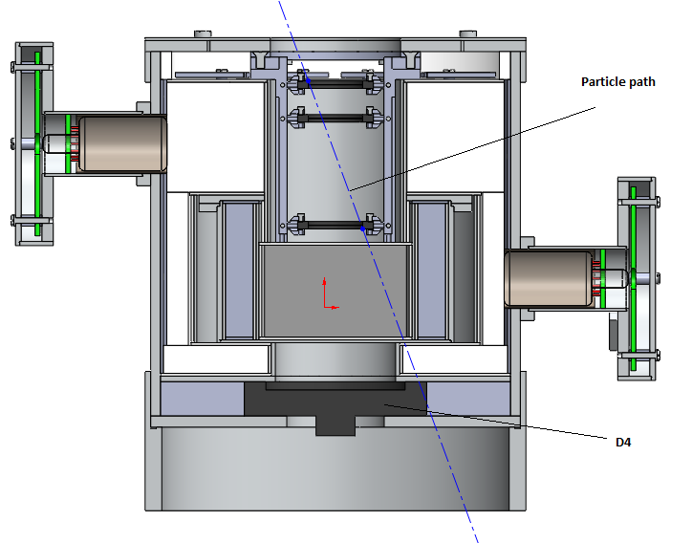

**Figure 12: D4 and particle path**

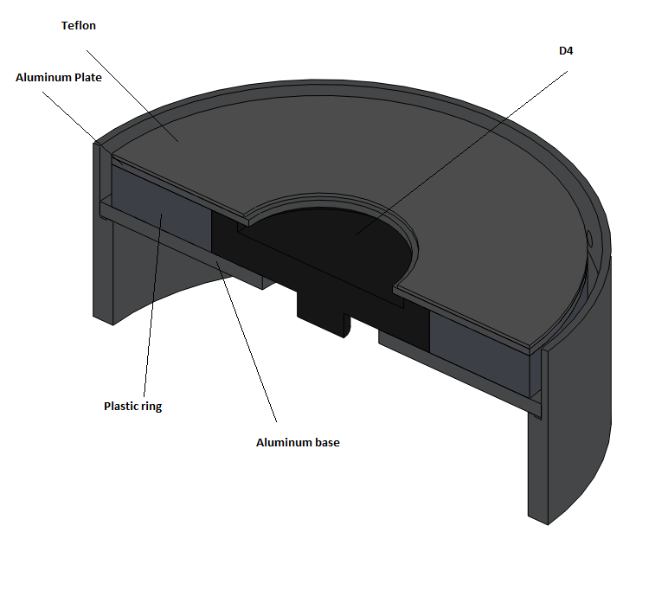

**Figure 13: D4 housing**

## Mushroom assembly

The purpose of the mushroom assembly is to provide a faraday cage around the circuit boards for horizontal photomultiplier tubes. These were designed to support the horizontal photomultiplier tubes, house the circuit boards and be capable of assembly and disassembly. This design is not Ideal due to the

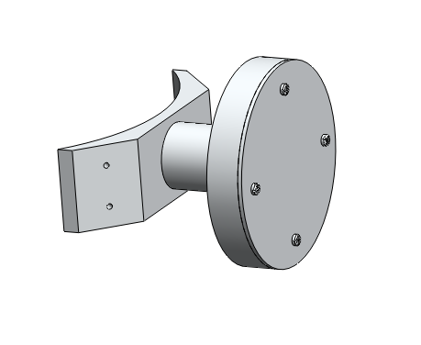

**Figure 14: Mushroom assembly**

## Full assembly

# 

**Figure 13: Full assembly**

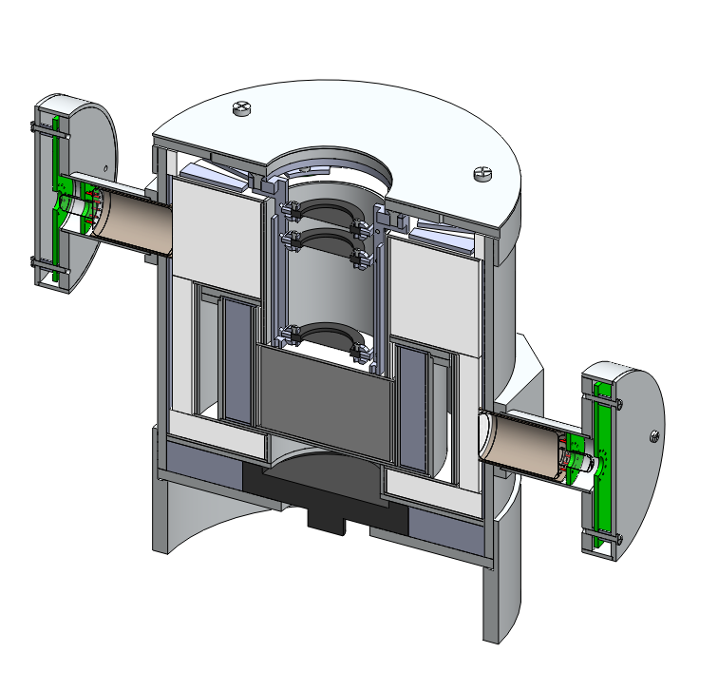

**Figure 14: Full assembly section view**

# Test plan

## Mechanical Design constraints

Light leaks - In order to provide efficient particle detection, ambient light outside the telescope must not be seen by any of the photomultiplier tubes.

Cross talk - When light is seen by any given scintillator, the same light should not be read by any other scintillator.

## Test procedure

For all procedures, the photomultiplier tubes and solid state detectors will be powered by a high voltage power supply. The output signal will be amplified by a pre amplifier amp into a amplifier and read by an oscilloscope and multichannel analyzer.

### Light leaks

To test for light leaks we will place the telescope in a well lit room and record the output signals. After the output signals are recorded, the lights will be shut off and a black velvet sheet will be placed over the telescope in order to block all incoming light. If the instrument is properly light proof, these signals should not significantly change.

### Cross talk

To test for cross talk between scintillators, an Alpha ray source will be culminated towards a single scintillator. If the scintillator is properly light tight, the only photomulipler tube that will produce a signal will be the one on that scinillator.

### Particle accelerator

Once the PICAP Instrument is finished, It will be brought to the Mass General Hospital proton beam and Idaho State cyclotron to be tested.

# Testing solid-state detectors

Solid-state detectors are a vital part of the Picap instrument. The Picap uses four solid-state detectors to detect and help identify particles that enter the front of the telescope. Electrons can be distinguished from more massive particles of the same total energy by their much lower dE/dx which generates no trigger in D1 and small signals in D2 and D3. Relativistic protons will produce a dE/dx signature similar to an electron but will also trigger D4. The purpose of testing these solid-state detectors is to determine the intrinsic noise produced by the detectors.

These solid-state detectors are also known as Semiconductor Radiation Detectors. These detectors use a semiconductor material, in this case silicon, as a detecting medium. These detectors are made by [doping](http://en.wikipedia.org/wiki/Doping_(semiconductor)) narrow strips of [silicon](http://en.wikipedia.org/wiki/Silicon) to make them into [diodes](http://en.wikipedia.org/wiki/Diode), which are then [reverse biased](http://en.wikipedia.org/wiki/P-n_junction#Reverse_bias). When a particle passes through the detector it will cause an ionization current which can be measured. The current measured can be used to determine the energy of the particle passing though. The intrinsic noise of the detector must be found to ensure the measured current is a correct correlation of the energy in the passing particle.

To test these detectors, an alpha radiation source, Americium-241, was columned towards the detector and the resulting signal was measured and recorded. The data recorded was then analyzed to fit a Gaussian curve which was used to calculate the intrinsic noise of the detector.

## Procedure

Four different solid detectors were tested to find the intrinsic noise.

|  |  |
| --- | --- |
| Solid-State detector | Thickness (µm) |
| 43-012B | 50 |
| 43-014B | 1000 |
| 43-014D | 1000 |
| 51-098C | 1000 |

### steps

1) The solid state detector was placed in a mounting fixture inside a vacuum chamber where the alpha source could be collimated towards the detector and bias leads could be attached.

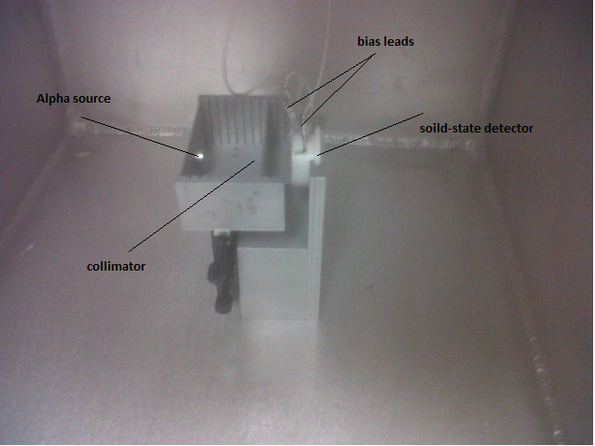

2) The bias leads from the detector were wired into a preamp which was wired to an amplifier, and wired to be powered by a power supply.

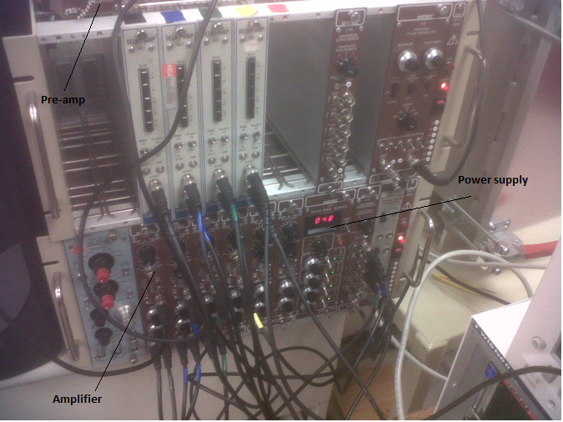

3) The signal from the amplifier was wired into an oscilloscope were it could be measured and wired to a multi-channel analyzer where the output signal could be recorded.

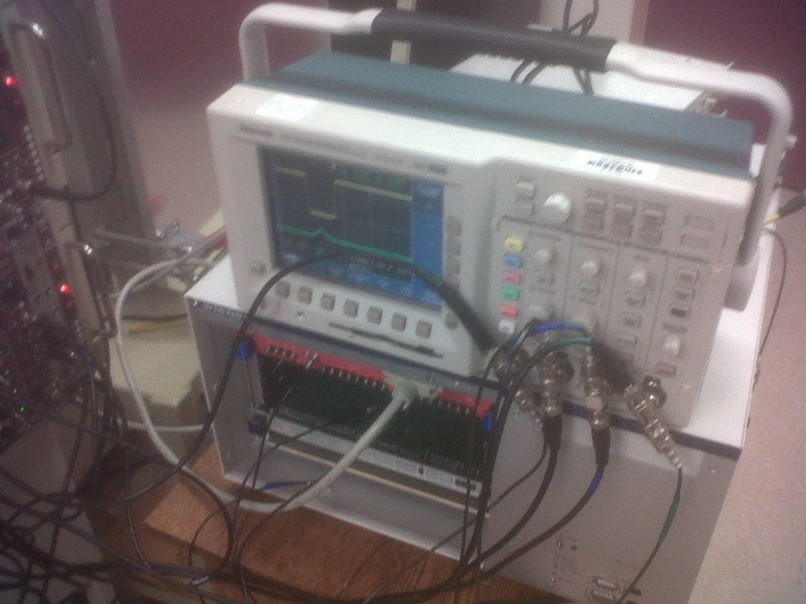

4) Once the wiring was complete, the gas chamber was closed and pumped down to 50 milil-Torr.

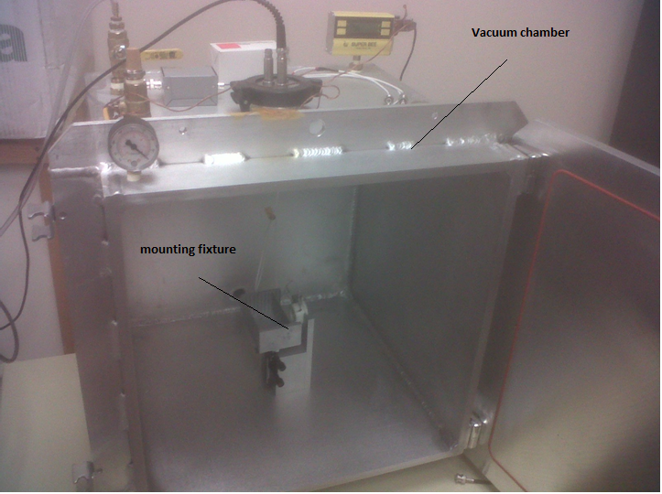

5) After the chamber is pumped down to at least 50 milil-Torr, the bias voltage for the solid state detectors was turned on to the manufactures specification and the output signals each event were recorded by the MCA for at least 10 hours.

## Analysis

To determine the intrinsic noise produced by the detector, first a Gaussian curve was fitted to the data recorded by the MCA. With this Gaussian curve both standard deviation and mean values could be determined based on the formula;

where is the initial amplitude, A is a constant, x is the number of events, is the mean value and σ is the standard deviation. The initial amplitude is equal to 0 because in channel one, it is assumed to have 0 energy.

Knowing that the MCA takes linear measurements, the energy per channel can be calculated by taking the known peak energy produced by the Americium-241 source and dividing by the mean of distribution.

The total energy associated with the standard deviation was than calculated by;

Due to the housing of the Americium-241 source, there is a slight energy loss through the titanium window that must be accounted for. This value was giving by the manufactures specification at 80.6KeV.

The standard deviation of the energy measured from the solid-state detectors was then calculated by;

# Analysis

This section includes analysis for the absorption probability of annihilation photons by the crystal material, a venting analysis, a thermal analysis and vibration analysis for the telescope. The purpose for probability of absorption calculations were to minimize the mass of the telescope while still ensuring efficient and accurate measurements of particles. The venting analysis was to ensure the change in pressure between the inside and outside of the telescope won't have adverse structural effects during launch. The thermal analysis was performed to ensure the temperature will not interfere with instrument's measurements or structural integrity while in orbit and vibration analysis was done to make certain that the telescope will not reach its natural frequency.

Due to the complexity and size of the actual design model, Soildworks was not able to perform computations for analysis. Many attempts were made to use the current state of the design but each time soildworks would fail in simulation for thermal, vibration and fluid flow analysis. After spending a great deal of time trying to get these simulations to work, a simplified version of the model was made so analysis could be preformed.

## Absorption probability

The original concept design for the telescope called for the crystal to be made from cesium iodide, after researching alternate materials, it was found that [bismuth germanate](http://en.wikipedia.org/wiki/Bismuth_germanate) would be a better substitute. Calculations show that [bismuth germanate](http://en.wikipedia.org/wiki/Bismuth_germanate) would save mass while still having the same absorption probability of annihilation photons as cesium iodide.

The probability of absorption can be calculated by:

(Leo)

Where;

I(x) = intensity as a function of x

= intensity

= Absorption cross section

Density

= probability of absorption

By setting probability of absorption of [bismuth germanate](http://en.wikipedia.org/wiki/Bismuth_germanate) to the probability of absorption for cesium iodide an equation was derived to find the equivalent size needed for [bismuth germinate:](http://en.wikipedia.org/wiki/Bismuth_germanate)

= .09 (

= 4.51

= 2.3 (cm)

= .14 (

= 7.13

.9353

Since the size of this crystal was one of the biggest driving components for the design of the telescope, the decision was made to change the material based on the ability to make the entire size of the device smaller.